TASK 2: Data Cleaning & Transformation
Task A (Duplicates): Identify employees who have same dob. Write a query to find these duplicates.
SELECT employee_fname,dob
FROM employee
WHERE dob IN (
SELECT dob
FROM employee
WHERE dob IS NOT NULL
GROUP BY dob
HAVING COUNT(*) > 1
)
ORDER BY dob;

Explanation:
This query identifies employees who share the same date of birth. It first finds dob values that appear more than once and then selects all employees with those dates, helping to detect duplicate or repeated entries.
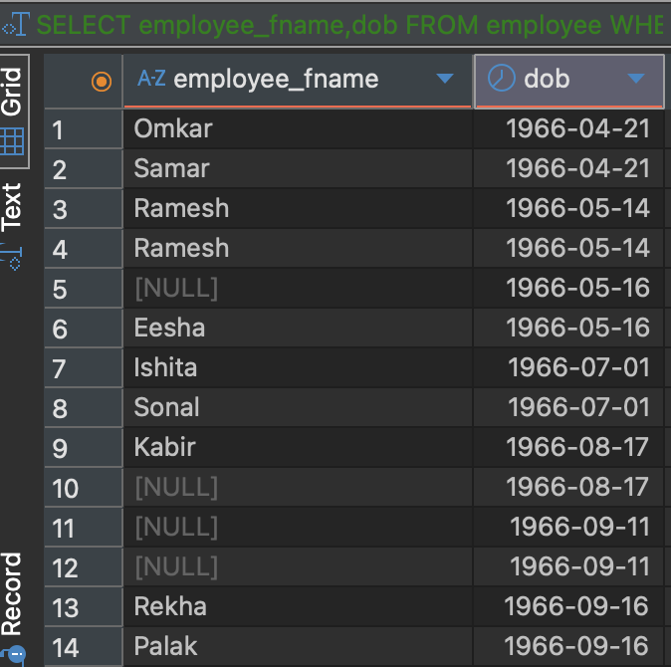

Task B (Null Handling): Return a list of employees; if the address is NULL, display 'Not Provided' instead. (Hint: COALESCE)

select employee_fname,
case
when address IS NULL then 'Not Provided'
else address
end as address
from employee;

Explanation:
This query returns a list of employees and replaces any NULL address with 'Not Provided' using a CASE statement. It ensures that missing address information is displayed in a user-friendly way instead of showing NULL.

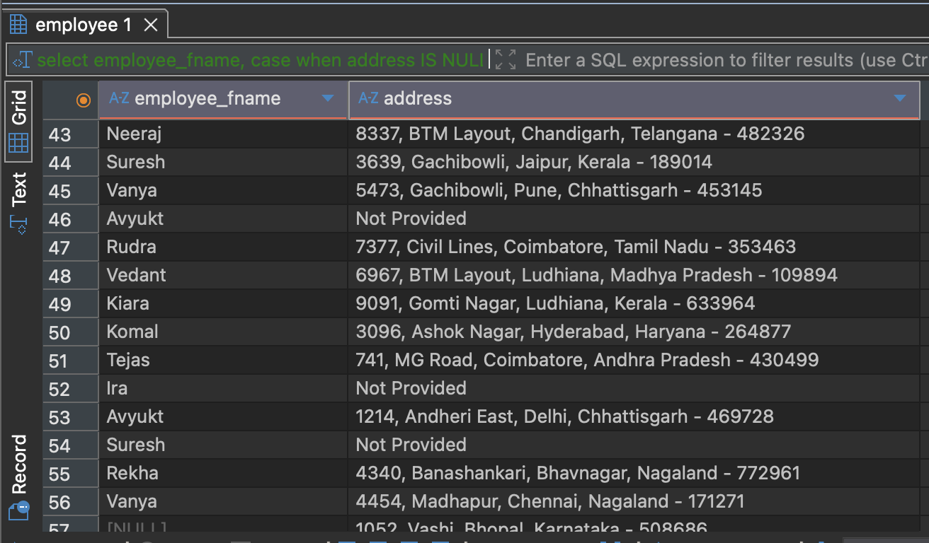

Additional Query — To handle missing or incomplete phone number data and present it in a readable, consistent format for reports or user interfaces.
Query:
SELECT employee_id,
COALESCE(employee_fname, 'Not Provided') AS firstname
FROM employee;

Explanation:
This query returns employees along with their phone numbers. If a phone number is NULL, it is replaced with 'Not Provided' using the COALESCE function, providing a clear indication for missing data.
